**Programing Code and Outcomes**

Cecilia Shields

MIS581-1

Chris den Heijer

July 7, 2022

*Figure 1: Summary Statistics*

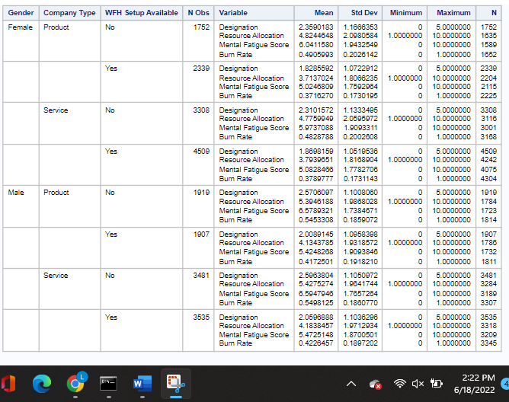

proc means data=WORK.BURNOUTDATA chartype mean std min max n vardef=df;

var Designation 'Resource Allocation'n 'Mental Fatigue Score'n 'Burn Rate'n;

class Gender 'Company Type'n 'WFH Setup Available'n;

run;

*Figure 2: Gender Bar Chart*

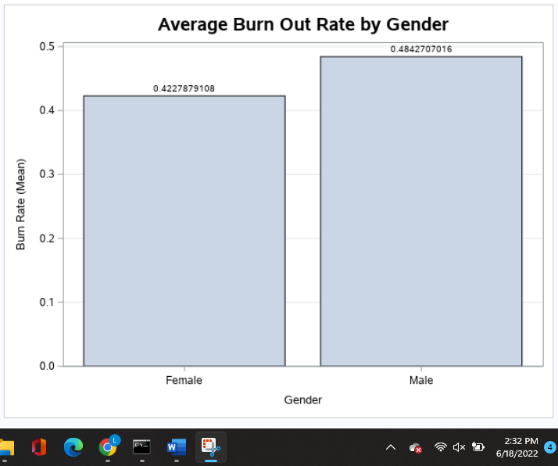

proc sgplot data=WORK.BURNOUTDATA;

title height=14pt "Average Burn Out Rate by Gender";

vbar Gender / response='Burn Rate'n datalabel stat=mean;

yaxis grid;

run;

ods graphics / reset;

title;

*Figure 3: Company Type Bar Chart*

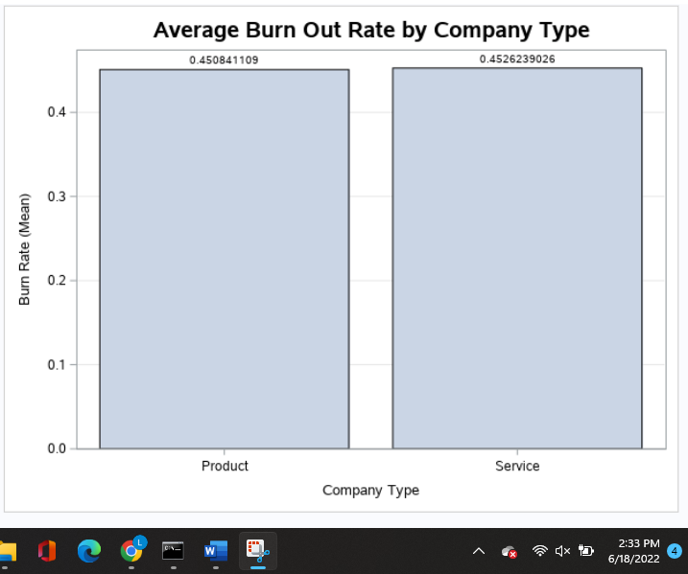

proc sgplot data=WORK.BURNOUTDATA;

title height=14pt "Average Burn Out Rate by Company Type";

vbar 'Company Type'n / response='Burn Rate'n datalabel stat=mean;

yaxis grid;

run;

ods graphics / reset;

title;

*Figure 4: Designation, Resource Allocation, Mental Fatigue Score Correlation Analysis*

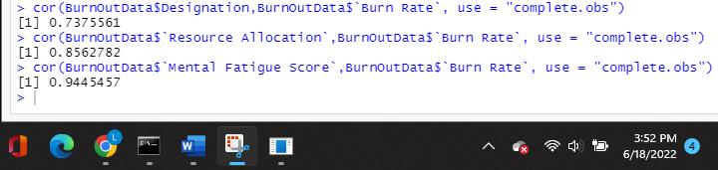

>cor(BurnOutData$Designation,BurnOutData$`Burn Rate`, use = “complete.obs”)

>cor(BurnOutData$`Resource Allocation`,BurnOutData$`Burn Rate`, use = “complete.obs”)

>cor(BurnOutData$`Mental Fatigue Score`,BurnOutData$`Burn Rate`, use = “complete.obs”)

*Figure 5: WFH Setup Bar Chart*

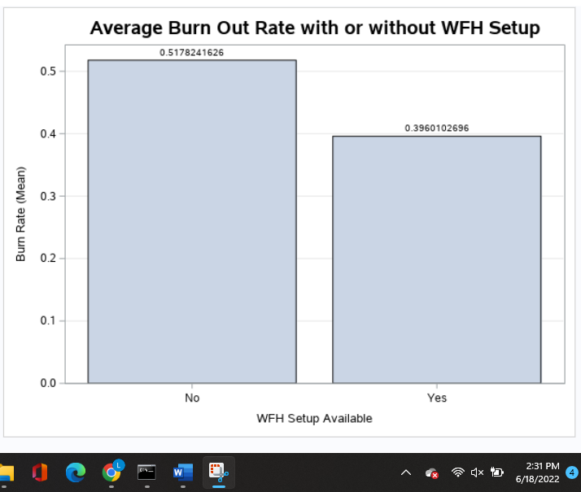

proc sgplot data=WORK.BURNOUTDATA;

title height=14pt "Average Burn Out Rate with or without WFH Setup";

vbar 'WFH Setup Available'n / response='Burn Rate'n datalabel stat=mean;

yaxis grid;

run;

ods graphics / reset;

title;

*Figure 6: Gender Pie Chart*

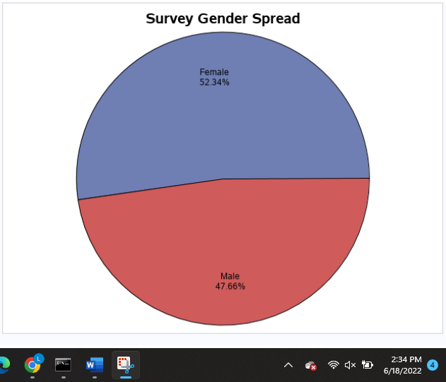

proc template;

define statgraph SASStudio.Pie;

begingraph;

entrytitle "Survey Gender Spread" / textattrs=(size=14);

layout region;

piechart category=Gender / stat=pct;

endlayout;

endgraph;

end;

run;

ods graphics / reset width=6.4in height=4.8in imagemap;

proc sgrender template=SASStudio.Pie data=WORK.BURNOUTDATA;

run;

ods graphics / reset;